Segment Shopping Customers:

Problem Statement- Understand the target customers for the marketing team to plan a strategy.

Context- Your boss wants you to identify the most important shopping groups based on income, age, and the mall shopping score.

He wants the ideal number of groups with a label for each.

Objective Market Segmentation:

Divide your mall target market into approachable groups. Create subset of the market based on demographics behavioural criteria to better understand the target for marketing activities.

The Approach:

1) Perform some quick EDA (exploratory data analysis)

2) Use KMEANS Clustering Algorithm to create our segments.

3) Use summary statistics on the clusters.

4) Visualize

Analysis: -

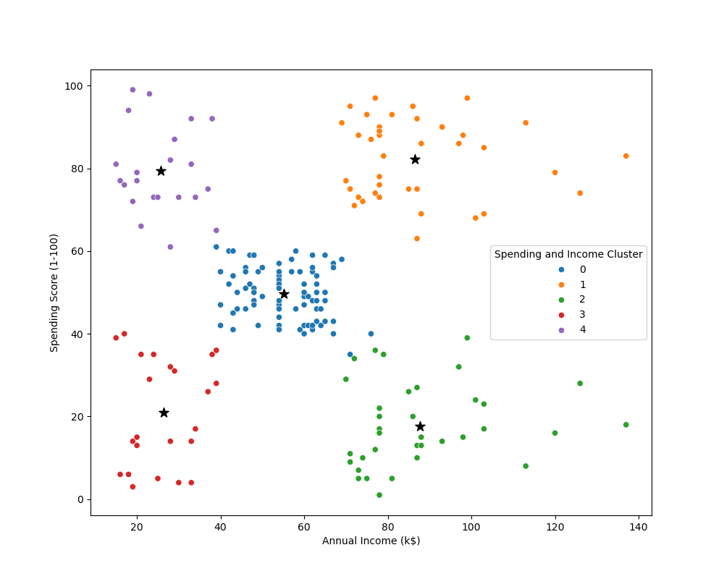

Target Cluster:

1. Target group would be cluster 4 which has a high spending score and high income.
2. 54% of Cluster 4 are women. We should look for ways to attract these customers using a marketing campaign targeting popular items in this cluster.
3. Cluster 4 presents an interesting opportunity to market to the customer for sales event on popular items.